**UNLOCKING INSIGHTS INTO THE GLOBAL AIR TRANSPORTATION NETWORK WITH TABLEAU**

**1.INTRODUCTION**

**1.1 Overview**

Global air transportation refers to the interconnected network of airlines, airports, and various supporting services that facilitate the movement of people, goods and information across the world by air.

**1.2 purpose**

* The purpose of global air transportation is to facilitate the movement of people, goods, and services across countries and continents.

*Global air transportation contributes to the exchange of ideas, technologies, and expertise on a worldwide scale, fostering global collaboration and understanding.

**2. PROBLEM DEFINITION & DESIGN THINKING**

**2.1 Empathy Map**

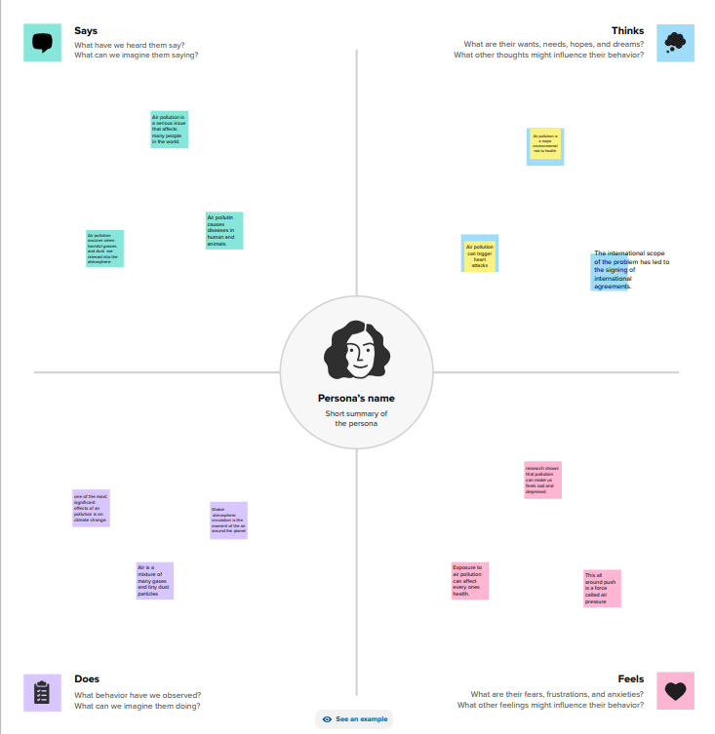

**2.2 IDEATION & BRAINSTROMING MAP**

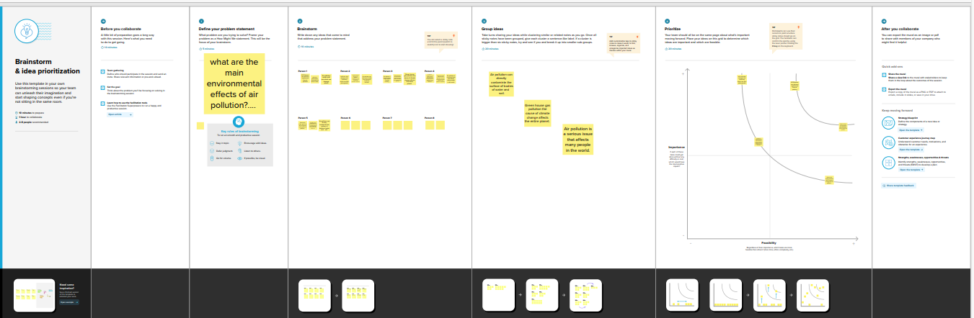

**3 RESULT**

**Dashboard 1**

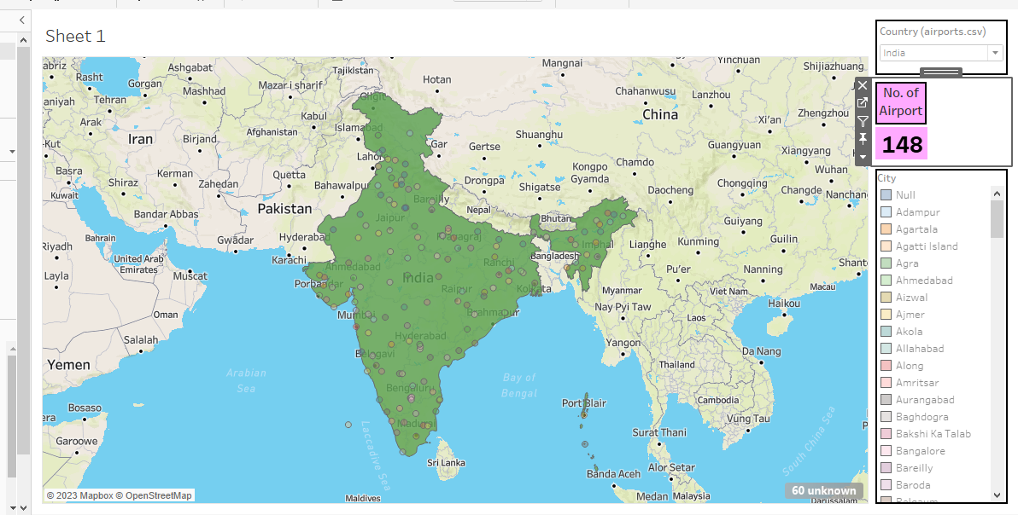

**Dashboard 2**



**Dashboard 3**

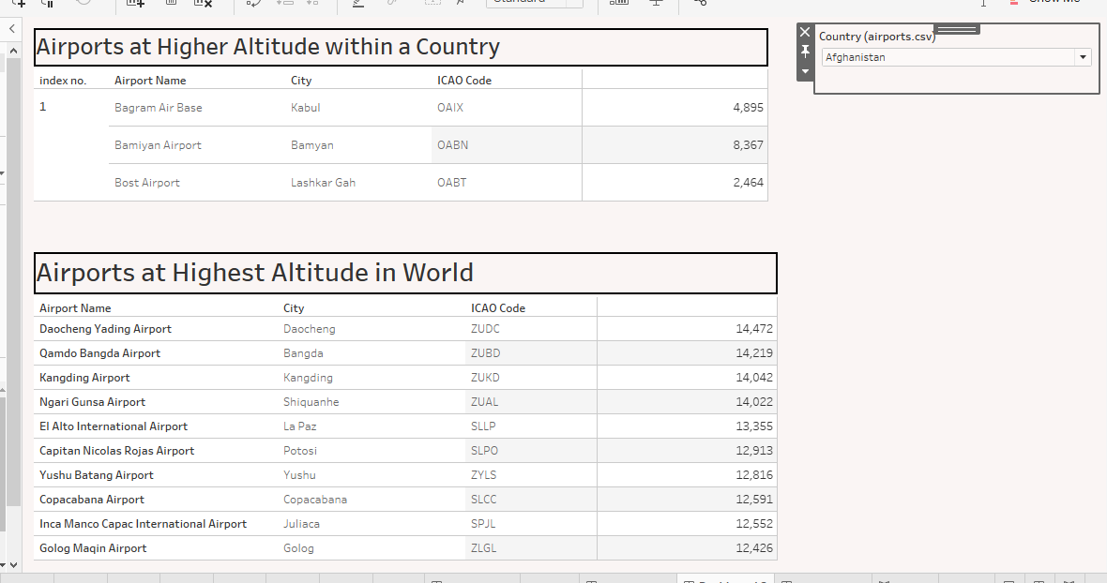

**Dashboard 4**

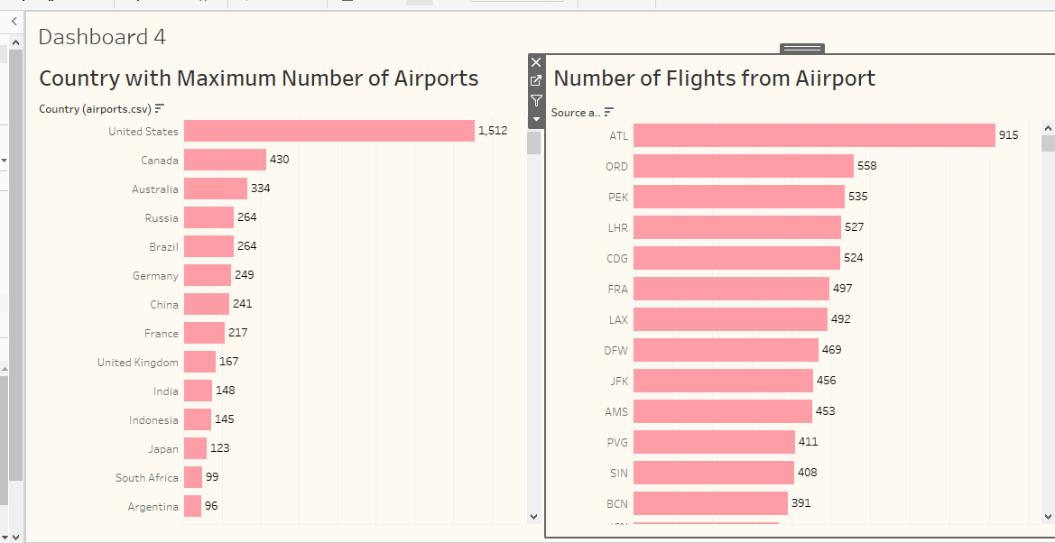

**Story**

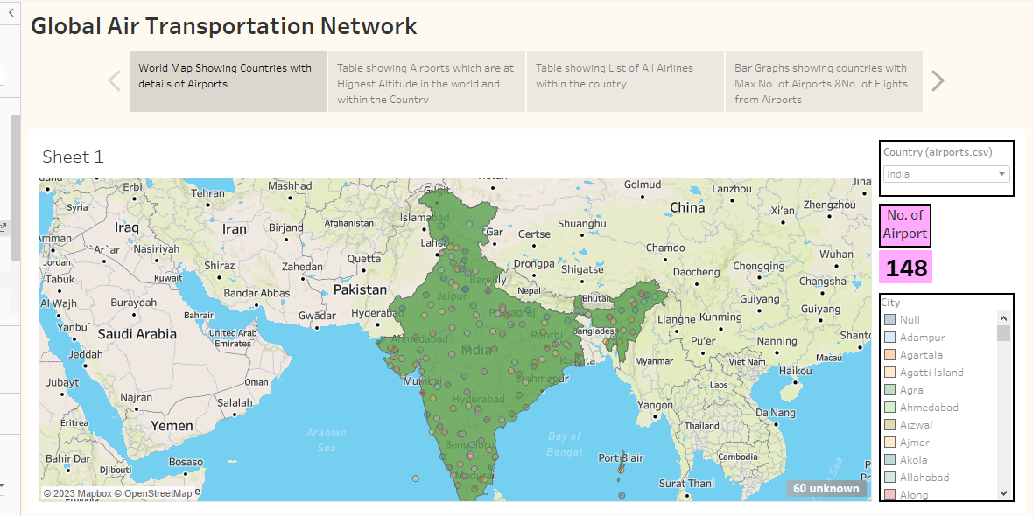

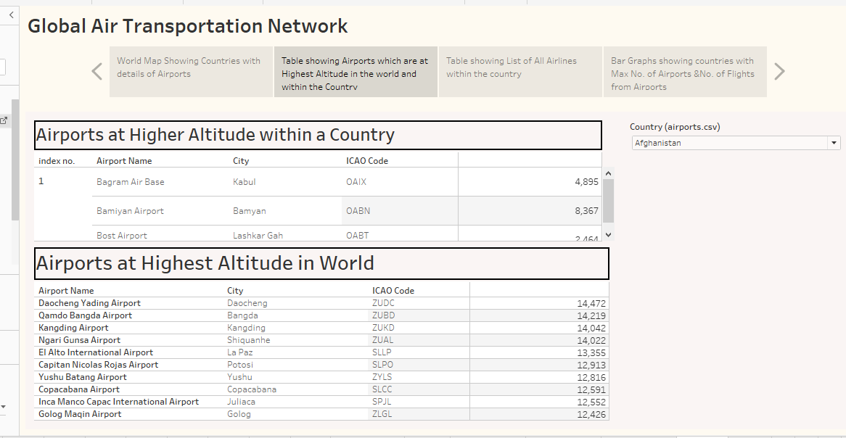

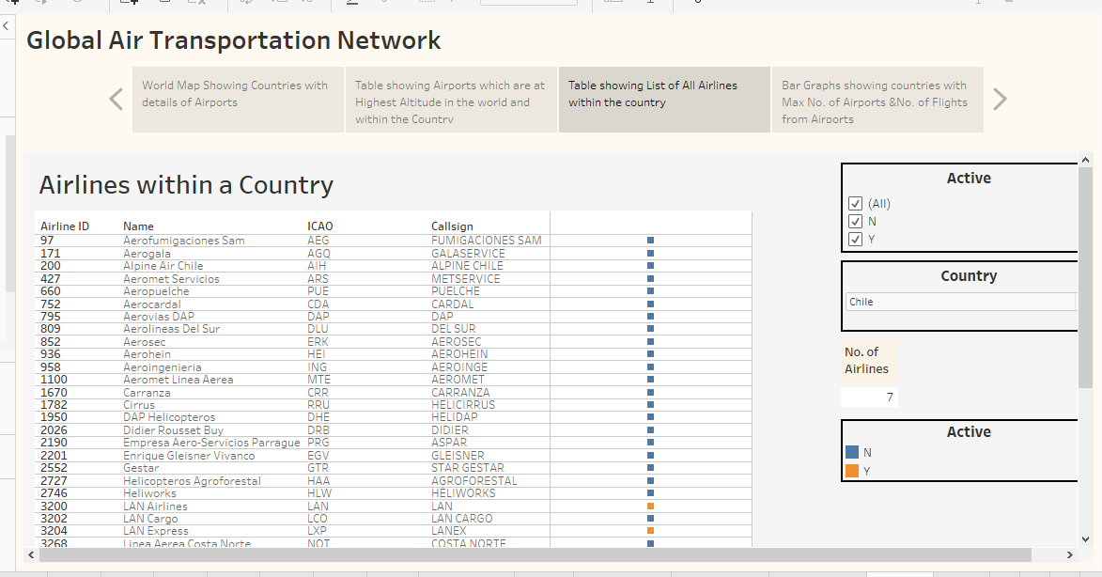

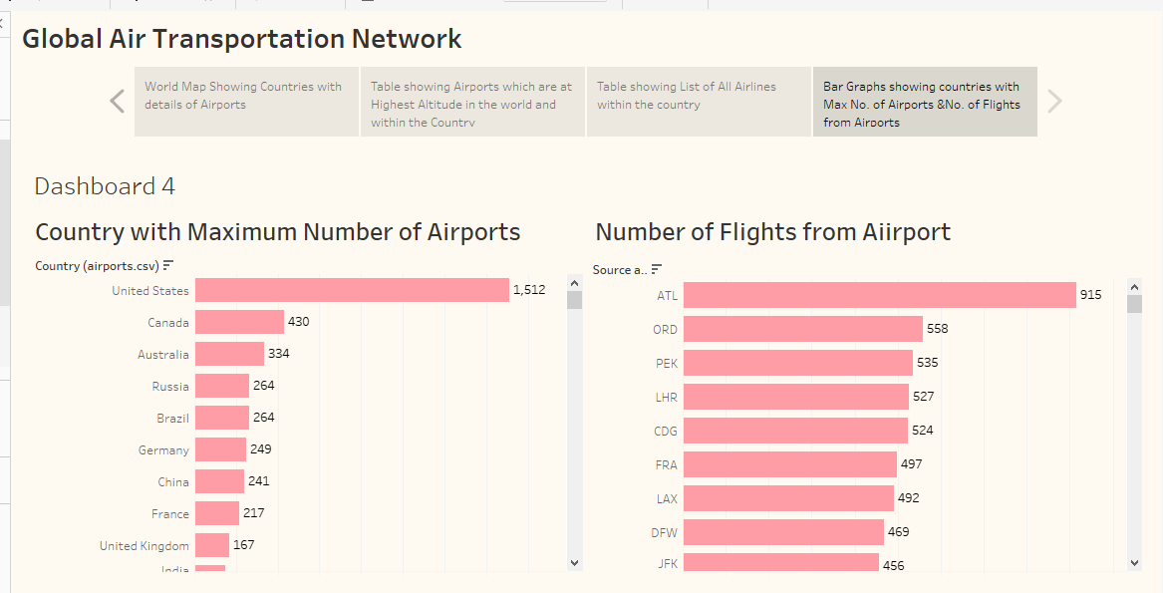

**4 ADVANTAGES & DISADVANTAGES**

**Advantages**

*Global air transportation offers numerous advantages, including fast travel, connectivity, accessibility to remote areas, and economic benefits.

* It allows people and goods to be transported quickly across long distances, fostering international trade and cultural exchange.

*Additionally, air travel promotes tourism, stimulates economic growth, and facilitates emergency response during crises.

**Disadvantages**

*Certainly, global air transportation also has its disadvantages.

*These include environmental impact due to greenhouse gas emissions, noise pollution near airports, and high energy consumption.

*Additionally, air travel can be costly, leading to economic disparities in travel opportunities.

**5 APPLICATIONS**

*Global air transportation has diverse applications, including passenger travel, cargo shipping, emergency response, tourism, and military operations.

*It facilitates international business by enabling executives to travel quickly between countries.

*Air transportation also supports medical emergencies by transporting patients and organs for transplantation.

**6 CONCLUSIONN**

In conclusion, global air transportation serves as a cornerstone of our interconnected world. Its advantages, such as fast travel, economic stimulation, and accessibility, have significantly impacted international trade, tourism, and emergency response.

**“ Connecting Continents, Bridging Cultures: Global Air Transportation – Where Dreams Take Flight!”**

**7 FUTURE SCOPE**

The future of global air transportation holds promising advancements and challenges. Advancements in technology, including supersonic travel, sustainable aviation fuels, and electric aircraft, will make air travel more efficient and environmentally friendly.